Radow Student Success Summit
May 13, 2024
Abigail Alexander (WLC) – alex100@kennesaw.edu

Globally Motivated: Enhancing student engagement through international community online

WLC Student Engagement Initiative: Cost-Free International Virtaul Exchange Program

I. Background
- Inherited strong virtual exchange (VE) relationship between KSU and Université Hassan II Casablanca
- Piloted French program in fall 2023 (in 2 FREN courses) and continued in spring 2024 (in 1 FREN course)

II. Motivation
- Community Building
- Real-World Utility
- Active Members of Global Society
- Boost Enrollment & Retention to Minor/Major

Questions for Participants:
- Would these motivators apply to your program?
- Are there other reasons a VE appeals to you?
- In which international area would you ideally seek a partner university or organization?
- What challenges can you imagine encountering?

III. Implementation
- Coordination - WhatsApp & Google Classroom
- Modifications for Modality
- Saga Lab AI Support
- NEH Humanities Initiatives Grant

Questions for Participants:
- Which modalities would benefit the most from this for your program?
- Is there a way the Saga Lab could support your program and/or VE?
- Is there interest in applying for a grant to support this implementation?

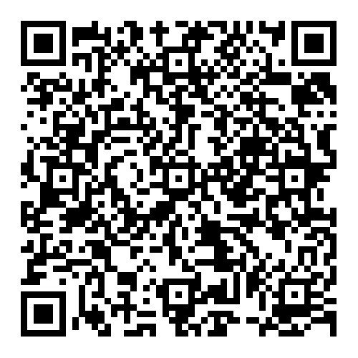
IV. Curricular Development
- Guiding Thread: “The Danger of a Single Story”
- Support Activities for Active Weeks (implemented Fall 2023)
- Introduction & Conclusion Activities (implemented Spring 2024)
- Google Slides Collaborative Multimedia Deliverable (for Fall 2024)

Questions for Participants:
- Do you have experience with similar collaborative activities?
- If so, what platform(s) do you find most helpful for collaborative work?
- If not, can you imagine how one could be incorporated in your program?

Interactive Activity :
- Please help me workshop this deliverable idea!
- Let’s assign a slide to each person starting at 2.
- Scan the QR code, open the link, find and download an image reflecting part of our conversation (especially as it applies to your program’s possible future with VE, AI, etc.), and share your image & 1 sentence of explanatory text to your slide on our collaborative multimedia deliverable from this summit!

