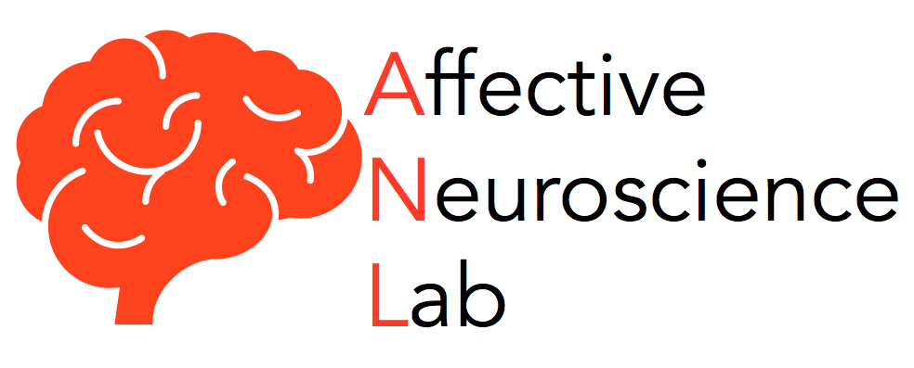
Application for Prospective Undergraduate Researchers

Thank you for your interest in the Affective Neuroscience Laboratory. All undergraduate researchers are encouraged to work among these collaborators and gain a range of research experiences.

Please fill out this survey honestly and thoroughly, and email it to eglove12@kennesaw.edu with “Undergraduate Research” in the subject line.

Once the survey is received, you will receive a follow-up email with further instructions.

1. Your Name:

2. Concentration/Major:

3. Expected graduation (month and year):

4. Current GPA:

5. Email address:

6. You will require a Dropbox account to access lab material. If you do not have a Dropbox account, please sign up for one via dropbox.com (it is free) and provide your Dropbox email:

7. Please list any neuroscience-, biology-, or chemistry-based courses you have taken and what grades you earned in them. Please note that taking these courses is not required, but preferred.

9. Do you have any prior research experience and if so, what did it entail?

10. Have you ever used statistics in a course or research setting? Please describe any relevant experiences.

11. If you know already, what do you hope to do after graduating college?

12. You would ideally like to work in the lab ________ hours per week (minimum = 4).

13. For now (Fall 2018 - this can be updated later), you are available to work in the lab (check all that apply, star your preferences):

Monday mornings (9-1)
Monday afternoons (1-5)
Tuesday mornings
Tuesday afternoons
Wednesday mornings
Wednesday afternoons
Thursday mornings
Thursday afternoons
Friday mornings
Friday afternoons
Weekend mornings
Weekend afternoons

Please include any comments or details to clarify your general summer availability:

14. Are you willing to commit to working in the lab for at least two semesters? If so, which ones? Please check all that apply.

Summer 2018
Fall 2018
Spring 2019
Summer 2019

Thanks for your interest!

