“This is Me” –Exploring Our Identities Due: 9/15/19
  - Meredith K. Ginn, COM 1100, Human Communication
Kennesaw State University

Purpose

This assignment ties to the following COM 1100 course learning outcomes (as referenced in the syllabus):

assessing your own communication skills

articulating characteristics of mediated messages

recognizing the influences of mediated messages on both senders and receivers.

Skills

The purpose of this assignment is to help you practice the following skills that are essential to your success in the course, at KSU, and in your professional life.
- Understanding your own identity and how it shapes your communicative behaviors. All communication begins with you, and understanding your unique self will allow you to become successful in the college classroom and in your future career.
- Analyzing the influence of culture, gender, and socialization on your identity and the identities of others. Audience analysis, empathy, and mutual understanding are needed in a variety of careers – from sales, to healthcare, to advertising and beyond.
- Selecting the aspects of your identity that matter most to you. Self-understanding is critical to successful relationships and career choices.
- Creating an Adobe Spark post that represents your identity through images and words. Students who have experience using software products like Adobe are more marketable to employers in our digital age.

Knowledge: This assignment will also help you to become familiar with the following important content knowledge within this discipline:
- Intrapersonal Communication
- Reflected appraisal
- Identity management
- Gender studies
- Cultural studies
- Empathy
- Personality
- Self-concept

Assignment Name: “This is Me” – Exploring Our Identities

Due Date: September 15, 2019

Task
Your mission for this out-of-class assignment is to create a graphic post using Adobe Spark. To get started with Adobe Spark, you should visit this following site: Welcome to Adobe Spark. All KSU students have access to Adobe Spark; simply go to Adobe Spark Homepage (spark.adobe.com) and click on "log in." You will then "login with school account" and put in your NetID and password.
For this assignment you will be creating a POST (you will also see Create a Page and Create a Video as options – so be sure you are choosing the Create a Graphic Post option). You should select an image that represents visually some aspect of your identity. You can find free photos, Adobe Stock images, or upload your own image. You should also include your full name and five words (or less) as description. For example, my cultural heritage of being a Southerner is important to me. I identify with the rhythm of the rocking chair and our slower Southern pace as a way to engage others in sweet conversation and to build relationships. Thus, I might create the following Adobe Spark graphic as a representation of me:
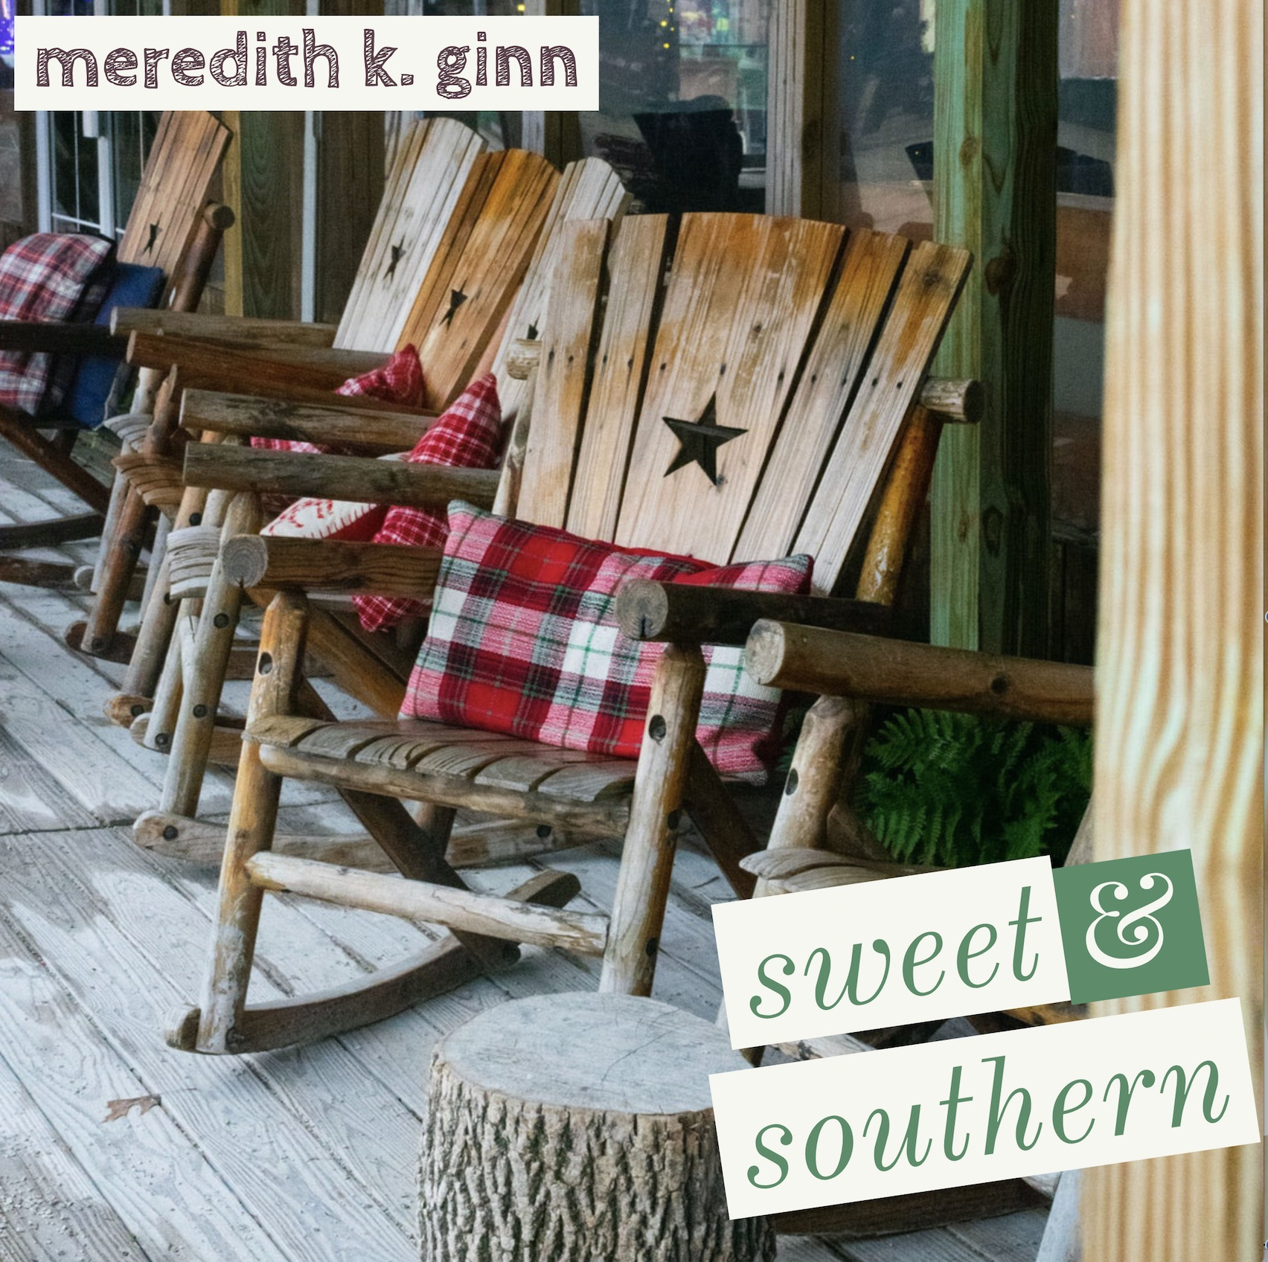

How would you describe yourself? What are the most important features of your identity? How is your identity related to gender, race, beliefs and the many roles you play? These are the questions that should guide your project creation.

All graphics should be posted to the discussion board on D2L entitled “This is Me” Discussion Board. Please note that all posts will be viewed by your instructor and classmates (so bear that in mind in terms of appropriate content and self-disclosure). Additionally, your posts might be shared as exemplars in the School of Communication and Media's Adobe repository. If you do not wish to have your post shared with SOCM, you must state that in writing by emailing mginn5@kennesaw.edu. Otherwise, it will be assumed that you are willing to share your post for learning purposes.

Assignment Name: “This is Me” – Exploring Our Identities

Due Date: September 15, 2019
CATEGORY | 0-1 Points | 2-3 POINTS | 4-5 POINTS | POINTS EARNED
Visual Appeal | An image is not present OR the image is blurry, cropped, and does not link well to written descriptors. | Image is present but could be more appealing. Color scape, scale, and focus could be improved. | Image is present, appealing, and connects well to the written descriptors. | ____/5
Written Descriptors | Written descriptors are missing or not thorough or contain spelling/grammar issues. | Written descriptors are present but could be more concise, grammatically correct, and link better to the image. | Written descriptors are present, concise, free from error, and appropriately convey the image. | ____/5
Name Identified | The student’s name is missing from the graphic post. | The student’s first or last name is identified, but the full name is not. | The student’s full name is identified on the post. | ____/5
Timeliness of Post | The student submits work after the deadline has passed.  (NOTE: it will be up to the instructor’s discretion if any late work will be accepted). | The students posts on the due date, but after class has begun. | The student posts by the deadline (all 5 points earned). | ____/5
TOTAL POINTS |  |  |  | SCORE: ____/20
Rubric/Criteria for Success

