PSYCHOLOGY RESEARCH EXPERIENCE (PREX)

In Introduction to General Psychology, you will study many intriguing topics - from the nature of dreams to causes of aggression to predictors of love and attraction. But really understanding psychology comes from doing as well as reading. How did psychologists obtain the research findings you read about in your textbook? What does the research process look like? That’s what the Psychology Research Experience (PREX) assignment is all about.

In PSYC 1101, 5% of the final course grade is earned through completing 3 credits (approximately 3 hours) of Psychology Research Experience (PREX) activities. To earn this 5% of your final grade, you have the option to participate in psychological research studies that you choose or to complete alternative assignments that do not involve participating in research but that serve as opportunities to learn more about the research process.
Important notes:
- Due to APA research guidelines, if you are a dual enrollment student or a student 17-years-old or younger, you are required to complete alternative PREX activities, versus PREX research participation.
- If you are 18 or older and not a dual-enrollment student, you may complete either research or alternative PREX activities – or a combination of both (e.g., 2 credits of research participation and 1 credit of alternative activity participation).
- There is no partial credit for this assignment. You must have completed 3 PREX credits by the participation deadline to earn the 5% PREX portion of your final course grade.
- To stay on track for successful completion of this assignment, it is recommended that you begin signing up for PREX activities by the 4th week of classes and complete at least 1.5 of the 3 required PREX credits by the semester midpoint.

Here are the options for completion of the PREX assignment
Option 1: Research Participation (open to students 18 or older who are not dual enrollment students). After the start date (see Important Fall 2022 SONA Dates below), you can use your KSU credentials to sign up to participate in one or more of the psychology research studies advertised in an online research management program called SONA (See “More Details About SONA” section below). You will find information about a study’s modality (in person or online) and PREX credits along with each study description. For online studies, students earn 1 credit for each 1 hour of participation. For in-person studies, students earn 1.5 credits for each 1 hour of participation. So, for example, if you complete a 2 hour in-person study, you earn 3 credits and fully meet your PREX requirement. Note that the particular studies found on SONA vary throughout the semester. So if you do not see a study you find interesting when you first log in to SONA, you might check back in a couple of weeks to see if new studies have been added. Just be mindful of the participation deadline as you plan your PREX activities.
Option 2: Alternative Research-related Activities (open to all students). After the start date (see Important Fall 2022 SONA Dates below), you can use your KSU credentials to sign up to participate in one or more of the alternative research-related activities advertised in an online research management program called SONA (See “More Details About SONA” section below). You will find information about an activity’s modality (in person or online) and PREX credits along with each activity description. All alternative research-related activity options have titles that begin with “Alternative Credit:”. For example, you might see an advertisement for “Alternative Credit: Cross-cultural Communication”. Some alternative activities involve reading and answering questions about psychology research articles (many co-authored by undergraduate psychology students!). Others may involve responding to questions about a video or a demonstration of a psychological phenomenon. No student responses in alternative activities are used for research purposes. Participation in these activities is for learning/demonstration purposes only. For online alternative activities, students earn 1 credit for each 1 hour of participation. For in-person alternative activities, students earn 1.5 credits for each 1 hour of participation. Alternative PREX activities will be available for the entire time span in which PREX research studies are available. Just be mindful of the participation deadline as you plan your PREX activities.
You are welcome to participate in additional PREX activities beyond the 3 required credits. Although no more than 3 credits will count toward your course grade, the more you learn about psychology research in PSYC 1101, the better idea you will have of the areas of psychology you might want to explore in later classes – and maybe you will even find yourself in a future role as a research assistant helping to conduct studies like the ones in which you participate this semester!

Important Fall 2022 SONA Dates
August 26th, 8:00am: Students can log into SONA using their KSU credentials
https://kennesaw.sona-systems.com/Default.aspx?ReturnUrl=/
December 5th, 5:00pm: Deadline for students to complete participation in either
research or alternative activities for PREX credit
More Details About SONA
- Important first step: To avoid potential error messages, you will want to clear your cookies and cache before attempting to log in to SONA.
- Go to https://kennesaw.sona-systems.com/Default.aspx?ReturnUrl=/ to log in to SONA. You should then see a screen that looks like this:
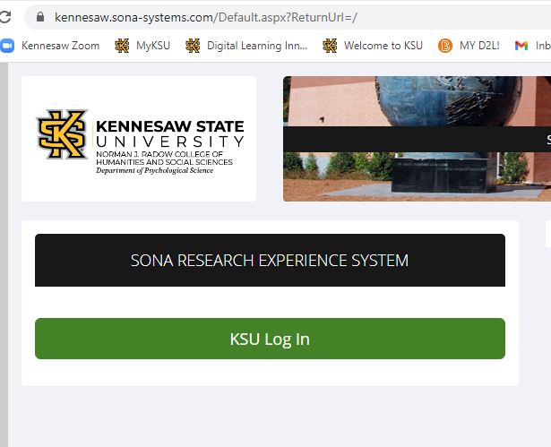

- You will now want to click on the green “KSU Log In” bar, after which you will be prompted to enter your KSU Net ID and password. You should then see a screen that looks like this (specific study and alternative activity availability varies throughout the semester, so the study/activity titles you see will be different than those seen in this image):
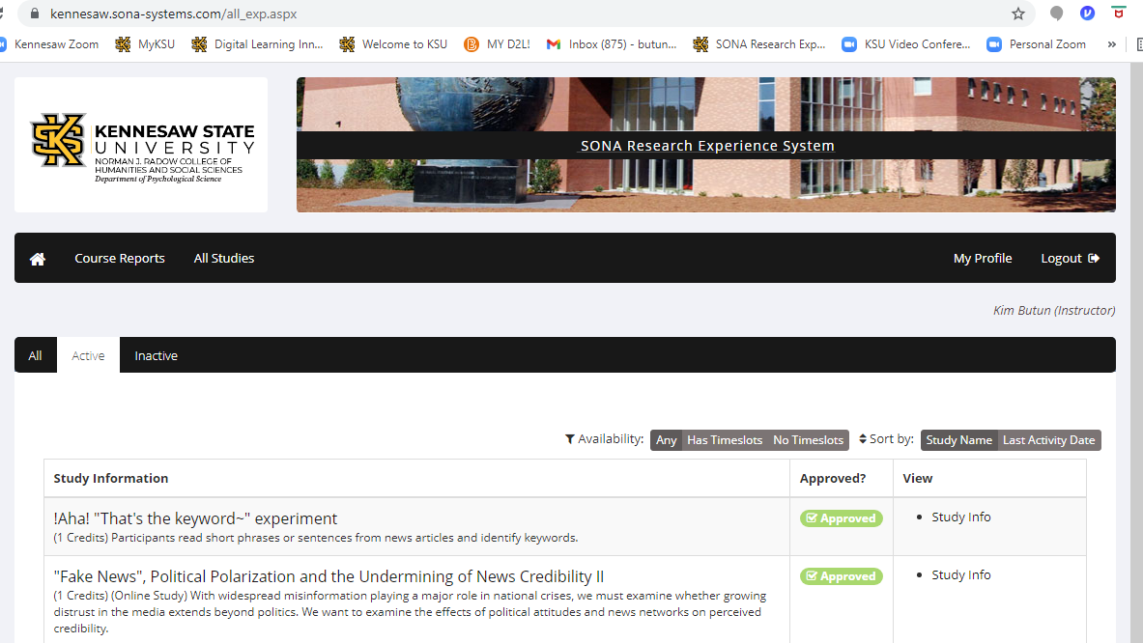

- You will find that next to where it says “Availability”, you have the option to limit your search to studies or alternative activities that have open time slots for which you can sign up.

- You can now read descriptions of the available studies and alternative activities, as well as find the number of PREX credits granted for each, and sign up for the ones you would like to complete.

- Just as a reminder - if you are required or would prefer to engage in alternative PREX activities, versus participating in research, you will sign up for activities with titles that begin with “Alternative Credit:”.
The Department of Psychological Science hopes you will enjoy your engagement in these psychology research and research-related experiences! Be sure to let your instructor or the research coordination team (psychresearch@kennesaw.edu) know if you have any questions.

